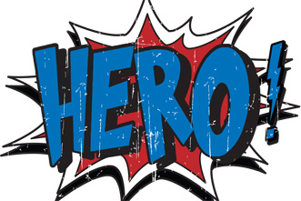
Name: ________________________________________________ Period: __________
Why do we learn history?
- What makes someone a hero? List at least 3 things.

- Who is your hero? Why?

- What do you think historians do? (If you don’t know, just guess)

- What is your favorite event in American history? Why?

- What is one goal you have for this school year?

